**The Relationship between UK GDP and Consumer Price Inflation**

Module: FC301 – Statistics

Student Name:

Student ID:

Tutor(s) name(s):

**The Relationship between UK GDP and Consumer Price Inflation**

**2. Introduction**

Consumer Price Inflation (CPI), a measure of inflation and prices, is the change in prices of a basket of goods and services over time (OECD 2023). Gross Domestic Product (GDP) on the other hand, measures the monetary value of finished goods and services produced by a country over time (Callen 2023).

This paper examines the statistical relationship between UK GDP growth and UK consumer price inflation from the first quarter of 2003 to the first quarter of 2023. The UK Office for National Statistics, through Kaggle datasets, provides quarterly data on GDP growth and inflation throughout this period.

The objective of the study is to evaluate the data on these two important economic metrics and establish whether there exists a relationship between GDP growth and CPI in the UK. Understanding the relationship between economic growth and inflation offers crucial insights or information about the state of macroeconomics in the United Kingdom.

**2.1 Research Questions**

1. What are the descriptive statistics and distribution of UK GDP quarterly growth data between 2003 and 2023?
2. What are the statistical descriptions and distribution of UK CPI quarterly data for the same period?
3. Is there a statistically significant relationship between UK GDP growth and CPI between 2003 and 2023? If yes, what is the strength and direction of the correlation?

**2.2 Data Collection**

To answer these questions, quarterly time series data on UK GDP growth and inflation from Q1 2003 to Q1 2023 were obtained from the Office for National Statistics database, which were accessible in Kaggle datasets. The data was then analyzed in Microsoft Excel to generate descriptive statistics, graphs, and charts, as well as conduct regression and correlation analysis.

The methodology for this analysis is presented in the following section. The statistical results are subsequently presented and analyzed to draw conclusions regarding the study problems.

**3. Methodology**

This section outlines the techniques and procedures used in this study to evaluate the relationship between GDP growth and consumer price inflation in the UK during a 20-year period, from 2003 to 2023.

For both datasets, descriptive statistics such as mean, mode, median, range, standard deviation, first quartile (Q1), third quartile (Q3), and interquartile range (IQR) were calculated using Microsoft Excel. These figures reflect each dataset's central tendency as well as spread.

Correlation analysis was used to investigate the statistical relationship between UK GDP growth and inflation rates. The correlation coefficient (r) shows the strength of the linear relationship between parameters, with values ranging from -1 to 1. The coefficient of determination (r2) shows how much of one variable's variance can be explained by another. In this case, r2 will show the proportion of variance in inflation that can be explained by GDP.

Regression analysis was conducted to fit a linear regression line that estimated inflation (%) from GDP growth (%). The slope and intercept values (model coefficients) of this line were interpreted. Residual plots were examined to determine whether a linear model was effective for this analysis.

On graph generation, histograms were used to visualize data distribution, box plots to identify outliers, and time series plots to analyze patterns, also known as trends, over time.

**4. Calculations and Graphs**

The following are the key descriptive statistics calculated for the quarterly UK GDP growth and consumer price inflation datasets from 2003 to 2023:

Table 1: Descriptive Statistics

|  |  |  |  |
| --- | --- | --- | --- |
| *UK GDP (%)* |  | *UK Consumer Price Inflation (%)* |  |
|  |  |  |  |
| Mean | 0.374074074 | Mean | 2.437037037 |
| Standard Error | 0.35070378 | Standard Error | 0.194741396 |
| Median | 0.5 | Median | 2.2 |
| Mode | 0.6 | Mode | 2.4 |
| Standard Deviation | 3.15633402 | Standard Deviation | 1.752672562 |
| Sample Variance | 9.962444444 | Sample Variance | 3.071861111 |
| Kurtosis | 34.84280529 | Kurtosis | 6.763322065 |
| Skewness | -2.169085779 | Skewness | 2.388180506 |
| Range | 37.6 | Range | 9.1 |
| Minimum | -21 | Minimum | 0.3 |
| Maximum | 16.6 | Maximum | 9.4 |
| Sum | 30.3 | Sum | 197.4 |
| Count | 81 | Count | 81 |

The mean quarterly GDP growth rate in the UK was 0.37% throughout the 81 quarters from 2003 to 2023. However, the median of 0.5% is higher than the mean, indicating that the distribution is skewed left, with more low GDP growth quarters as shown in the histogram and box plot below. The enormous standard deviation of 3.16% demonstrates a high volatility in GDP growth.

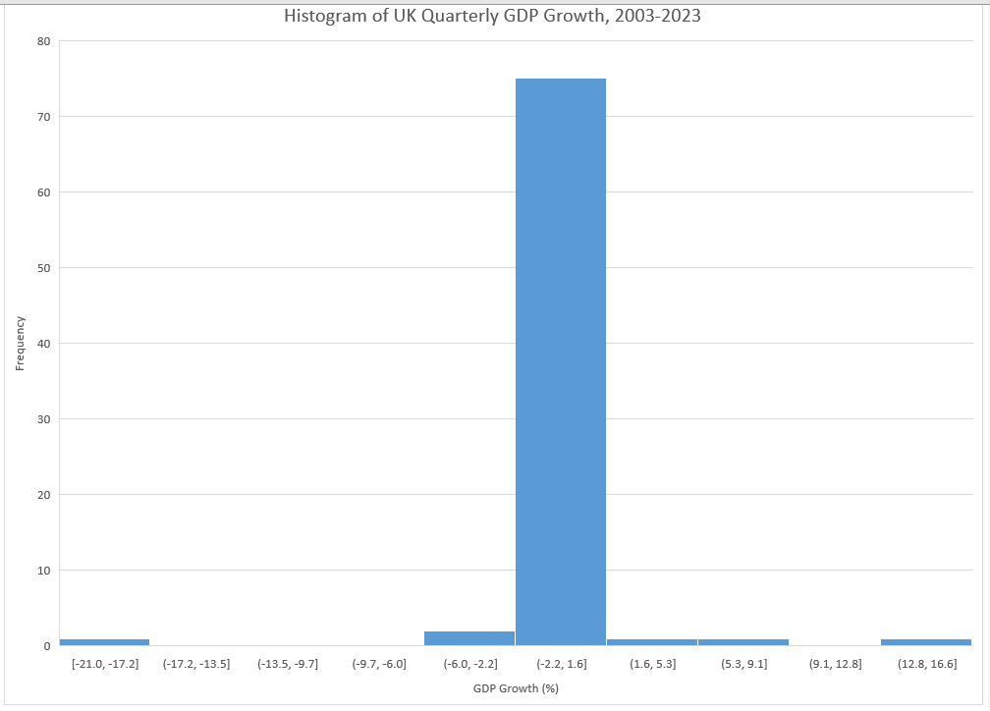

The kurtosis of 34.8 indicates a distribution that is significantly more peaked than a normal distribution. This corresponds to a time series with periodic substantial GDP changes. The skewness of -2.17 suggests that the data is asymmetrically distributed, with a large left tail of low or negative GDP growth rates, shown in the figure below.

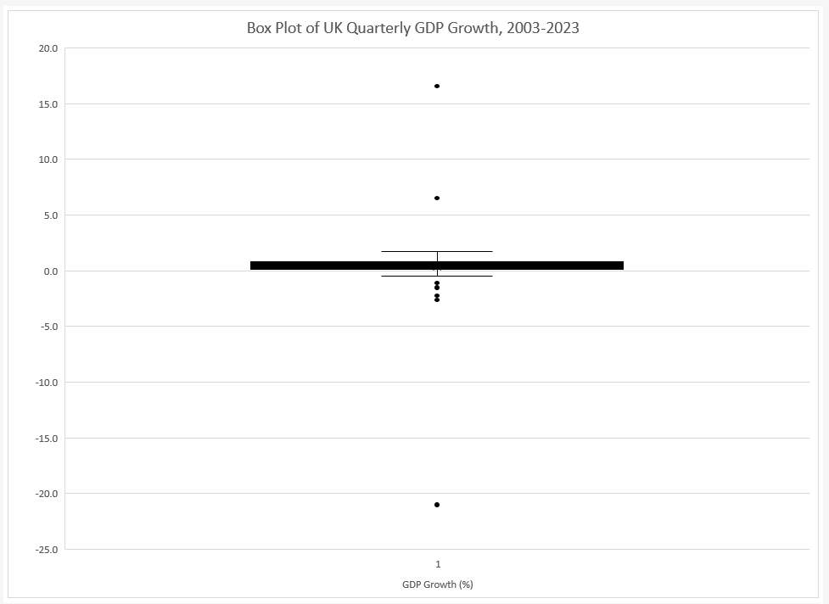

Overall, the descriptive statistics demonstrate that UK GDP growth during this period varied significantly from quarter to quarter.

The average UK inflation rate of 2.44% implies that prices are rising considerably on average as shown in the box plot below.

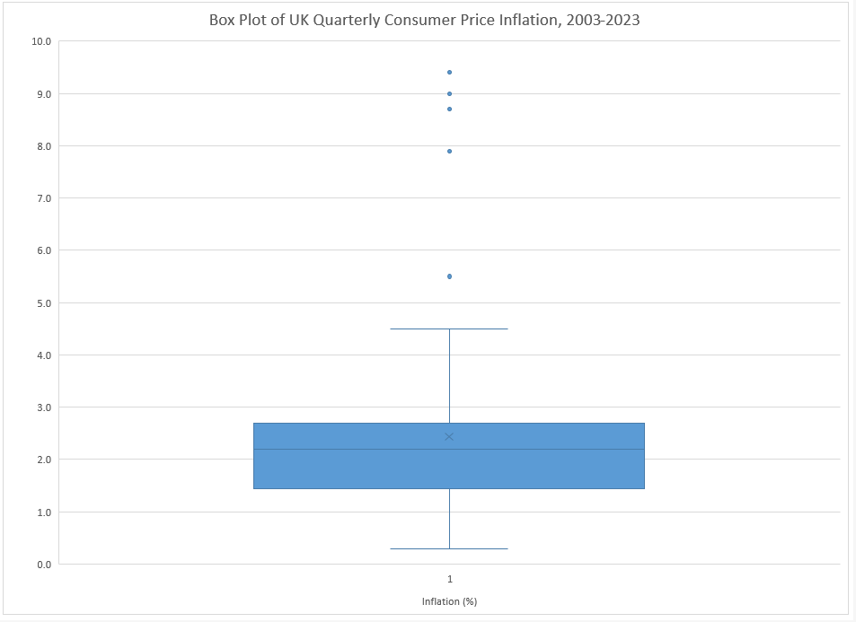

The median and mode are close to the mean, indicating a generally symmetric distribution as indicated in the histogram below. The standard deviation of 1.75% reflects a more modest dispersion of inflation than GDP growth.

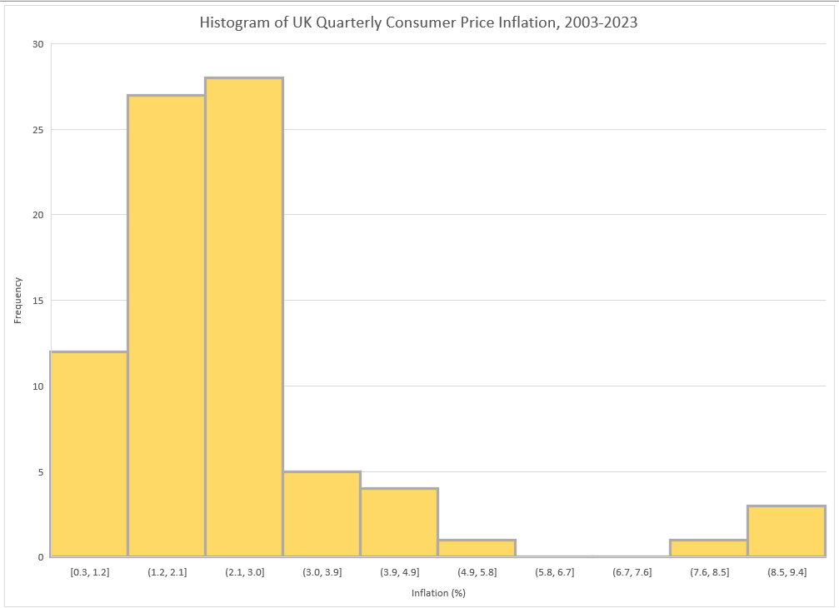

The kurtosis of 6.76 suggests that the distribution is slightly peaked than normal. The positive skewness of 2.39 is consistent with the asymmetric right tail of higher inflation rates. Overall, inflation is substantially less volatile than GDP growth over this period. The spread of inflation is limited to a relatively narrow band from quarter to quarter. Also, it is important to note that neither of the box plots has an outlier. This implies that the whole data under investigation fit within their respective ranges. That is to say, no data is found above the maximum values or below the minimum values.

**5. Analysis of Data**

1. **Correlation**

A correlation analysis between quarterly UK GDP growth and inflation yields the following:

Table 2: Correlation Table

|  |  |  |
| --- | --- | --- |
|  | *UK GDP (%)* | *UK Consumer Price Inflation (%)* |
| UK GDP (%) | 1 |  |
| UK Consumer Price Inflation (%) | -0.025831934 | 1 |

Correlation coefficient (r) = -0.025831934

Coefficient of determination (r2) = 0.0007

The negative correlation coefficient indicates a negative linear relationship between GDP growth and inflation. As GDP growth increases, inflation tends to slightly decrease.

For the coefficient of determination, the low r2 value implies that only 0.07% of the variation in consumer price inflation is explained by changes in GDP growth. This can only mean that many other factors also influence inflation. They include fuel prices, Strong global demand for consumer goods, and supply chain disruption among others (Francis-Devine et al. 2023).

1. **Regression**

The regression line represents the estimated average relationship between the two variables. The negative slope indicates that higher GDP growth correlates with lower inflation on average. In terms of strength, the gently sloping regression line portrays a weak correlation between the two variables. This is also evident by the nearness of correlation coefficient (-0.026) to 0,

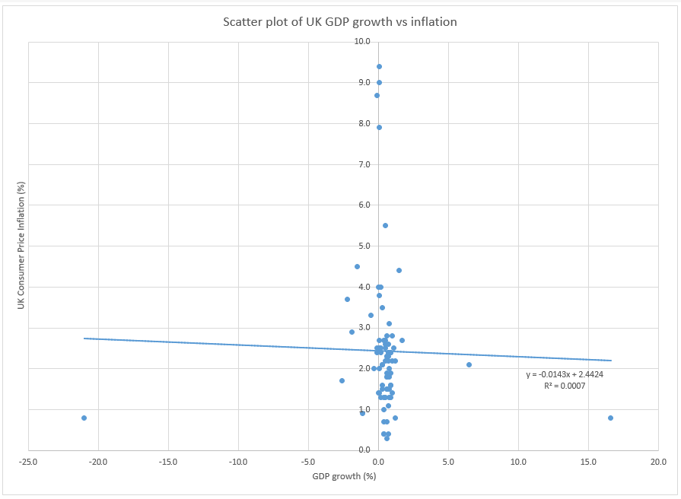

From the above scatter plot, the linear regression equation estimating inflation from GDP growth is:

Predicted CPI = 2.4424 – 0.0143*GDP Growth

The slope of -0.0143 implies that for every 1% point increase in GDP growth, inflation decreases by -0.0143% points.

The intercept of 2.4424% represents the estimated inflation baseline level when GDP growth is zero.

The regression line fits the data moderately well, explaining 0.07% of the variation in inflation based on GDP growth. The standard error of the regression is 1.76%.

Residual analysis shows no systematic patterns, indicating linear regression is appropriate. The variability of inflation around the regression line reflects the many other factors (macroeconomic indicators) that influence it beyond just GDP growth.

1. **Time Series**

The time series plot of UK GDP growth shows significant volatility from 2003 to 2023. GDP swings from quarter to quarter, with some recessions noticeable as extended spells of negative growth. The lowest points were reached during the 2008-2009 global financial crisis and the 2020 COVID pandemic, which induced a recession. Aside from contractions, growth slowed significantly during the 2011-2012 Eurozone crisis era (Benczes & Szent-Ivanyi 2015).

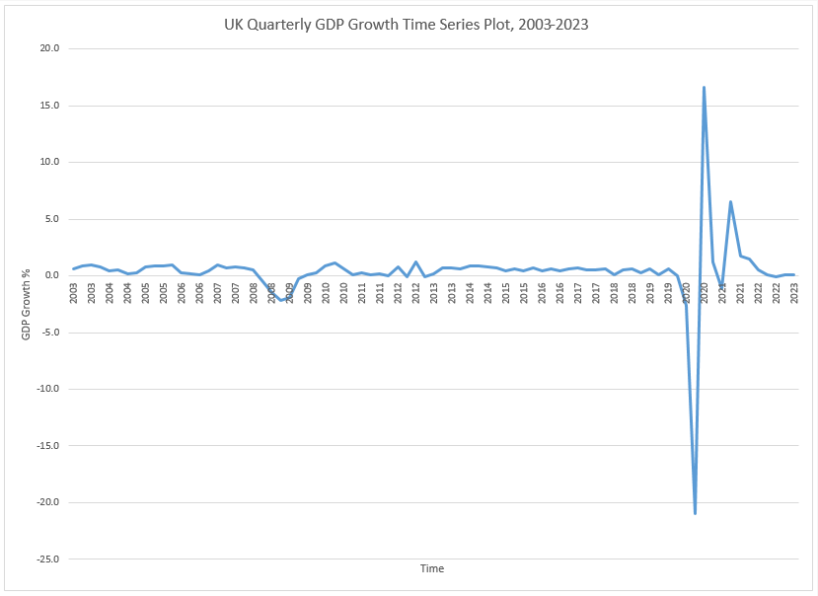

Short phases of expansion are seen in 2004-2006 and 2010, with consecutive quarters of positive GDP growth exceeding 1%. Overall, the time series captures the cyclical nature of the UK economy over the past two decades.

On the other hand, the time series graph below shows that in the last two decades, the UK registered the lowest inflation of 0.3% in 2015 due to the low cost of food and motor fuels (www.ons.gov.uk, n.d.).

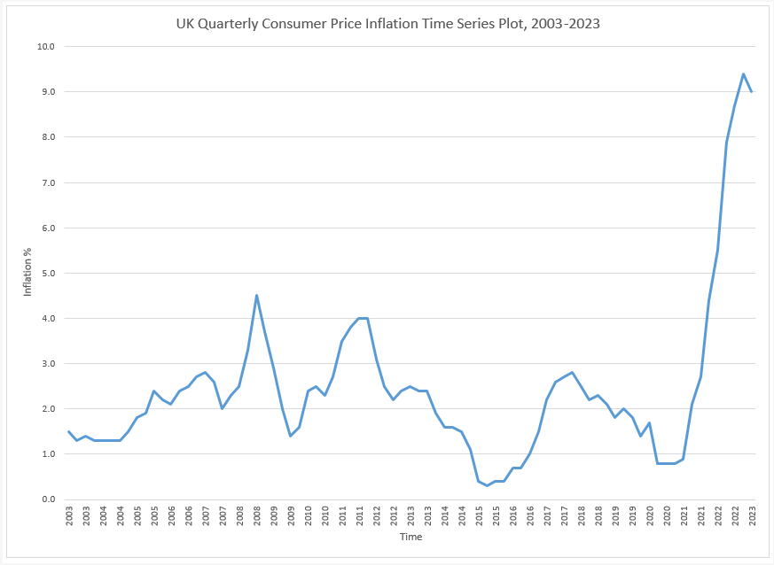

On the other hand, the UK experienced a rapid positive change in inflation percentage i.e. from about 1% in 2021 to 9.4% in 2022 mainly because of high prices of food and energy as a result of the Russia-Ukraine conflict, which cut the supply of goods to UK (Francis-Devine et al. 2023).

**Future Prediction**

The graph below shows UK GDP growth forecast from 2010-2028 using the 2003-2023 UK GDP data. A decrease in GDP growth (%) is expected for the next five years, i.e. from 2023 to 2028. These future predictions differ from OECD.org economic outlook (2023), which shows that the UK GDP will grow by 0.7% in 2024 and 1.2% in 2025.

For inflation, the graph below shows inflation predictions from 2010 to 2028 using the 2003-2023 quarterly consumer prices inflation data.

The general trend in the graph shows that the UK inflation will gradually go up for the next five year. According to Michael (2024), inflation in UK is still expected to sit above the government’s target (2%) in 2024 due to damaging economic conditions.

Based on the two forecasted graph, the researcher cannot rely on the results shown due to limited variables. To improve the forecasts, one should use more advance techniques such as machine learning algorithms, which include Decision Tress, Random Forests, and XGBOOST Gradient Machine.

**6. Conclusion**

This report investigated the statistical relationship between UK GDP growth and consumer price inflation from 2003 to 2023. The investigation revealed that GDP growth over this era was highly volatile, with a mean of 0.37%. Inflation remained more constant, averaging 2.44%. The research questions were answered using descriptive statistics, correlation analysis, regression modeling, and time series charts. The small negative correlation of -0.026 between GDP growth and inflation was unexpected, given that economic theory predicts a positive association. However, the near-zero correlation suggests that GDP growth has a minor linear relationship with inflation based on this dataset.

The regression model revealed a slightly negative slope, indicating a 0.0143% fall in inflation for every 1% increase in GDP growth. However, the model explained only little of the variation in inflation. The time series charts contrasted the higher frequency variations in GDP with the more consistent inflationary trends. In conclusion, while increased GDP growth frequently leads to some inflationary pressure, many other stronger macroeconomic factors have a significant impact on UK consumer prices. GDP-based models appear insufficient to explain inflation trends. To further understand the factors that contribute to inflation, further research with more macroeconomic variables and sophisticated time series techniques is advised. Instead of depending solely on GDP estimates, monetary policy may necessitate a more comprehensive approach that takes into account a variety of variables.

**References**

Benczes, I. and Szent-Ivanyi, B., 2015. The European economy in 2014: Fragile recovery and convergence. *J. Common Mkt. Stud.*, *53*, p.162.

Callen, T. (2023). *Gross Domestic Product: an Economy’s All*. [online] International Monetary Fund. Available at: <https://www.imf.org/en/Publications/fandd/issues/Series/Back-to-Basics/gross-domestic-product-GDP#:~:text=GDP%20measures%20the%20monetary%20value>.

Francis-Devine, B., Harari, D., Keep, M., Bolton, P., Barton, C. and Carthew, H. (2023). Rising Cost of Living in the UK. *House of Commons Library*, [online] 9428(1). Available at: <https://commonslibrary.parliament.uk/research-briefings/cbp-9428/>.

<https://www.kaggle.com/datasets/matarrgaye/uk-gross-domestic-product-quarterly-1955-2023?select=series-120623.xls>

<https://www.kaggle.com/datasets/matarrgaye/uk-consumer-price-inflation-quarterly-and-annual?select=series-100623.xls>

<https://www.oecd.org/economic-outlook/november-2023/>

Michael, A. (2024). *Inflation Outlook 2024*. [online] Forbes Advisor UK. Available at: https://www.forbes.com/uk/advisor/investing/inflation-outlook-2024/.

OECD (2023). *Prices - Inflation (CPI) - OECD Data*. [online] The OECD. Available at: <https://data.oecd.org/price/inflation-cpi.htm>.

www.ons.gov.uk. (n.d.). *Consumer price inflation, UK - Office for National Statistics*. [online] Available at: <https://www.ons.gov.uk/economy/inflationandpriceindices/bulletins/consumerpriceinflation/2015-05-19>.

**8. Appendices**

**8.1 Sample of the Dataset**

**8.2 Excel Screen Shots**

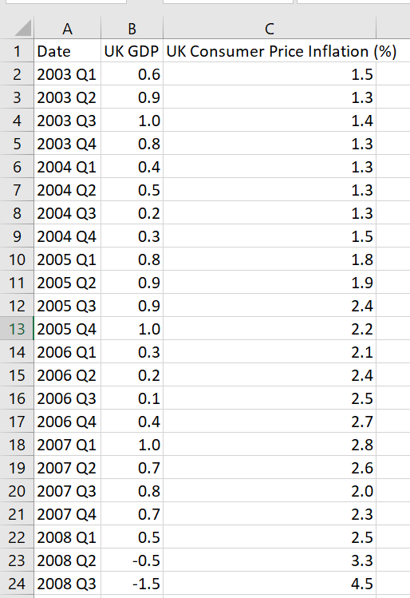

**Regression Analysis**

|  |  |  |  |  |  |  |  |  |
| --- | --- | --- | --- | --- | --- | --- | --- | --- |
| SUMMARY OUTPUT | |  |  |  |  |  |  |  |
|  |  |  |  |  |  |  |  |  |
| *Regression Statistics* | |  |  |  |  |  |  |  |
| Multiple R | 0.025832 |  |  |  |  |  |  |  |
| R Square | 0.000667 |  |  |  |  |  |  |  |
| Adjusted R Square | -0.01198 |  |  |  |  |  |  |  |
| Standard Error | 1.763142 |  |  |  |  |  |  |  |
| Observations | 81 |  |  |  |  |  |  |  |
|  |  |  |  |  |  |  |  |  |
| ANOVA |  |  |  |  |  |  |  |  |
|  | *df* | *SS* | *MS* | *F* | *Significance F* |  |  |  |
| Regression | 1 | 0.163985 | 0.163985 | 0.052751 | 0.818937 |  |  |  |
| Residual | 79 | 245.5849 | 3.10867 |  |  |  |  |  |
| Total | 80 | 245.7489 |  |  |  |  |  |  |
|  |  |  |  |  |  |  |  |  |
|  | *Coefficients* | *Standard Error* | *t Stat* | *P-value* | *Lower 95%* | *Upper 95%* | *Lower 95.0%* | *Upper 95.0%* |
| Intercept | 2.442403 | 0.197293 | 12.37959 | 3.47E-20 | 2.049701 | 2.835104 | 2.049701 | 2.835104 |
| UK GDP (%) | -0.01434 | 0.062454 | -0.22968 | 0.818937 | -0.13866 | 0.109967 | -0.13866 | 0.109967 |